Unit Two: Founding the American Colonies
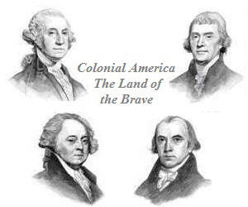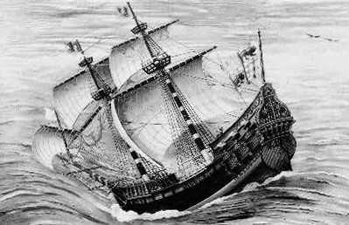

WHAT to KNOW:
- The major events preceding the founding of the nation
- Significance of the development of American Constitutional Democracy
- Blend of civic republicanism, classical liberal principles, and English parliamentary traditions
- Describe the relationship betweem the moral & political ideas of the Great Awakening

Vocabulary Terms:
cash crops assembly democratic Puritans
slave trade economy rights Parliament
petition (verb) class First Great Awakening conquistadors
colony missionaries trappers

